PROJECT 2 – LOAN LANDING PAGES:

- Improve UI design similar to that of banking bridge (see images below). There will only be 2 landing page styles, nothing more. It needs good UI and functionality on both desktop and mobile phone. However, it’s important that we do not copy their material, as it is a copyright infringement.
  - Competitor:
    - https://www.bankingbridge.com/landing-page/landingpage1

- Implementation of API INTEGRATION with Optimal Blue – for loan rate cards and loan pricing (API information Attached)

- Requires SUPER ADMIN features, similar to that of widget below:

  - https://widget.mymortgage360website.com/
Login: admin@example.com
Pass: 123456

- SUPER ADMIN– to oversee subscriptions. Subscribers (Companies and individuals) can update their profiles in app but will not be able to see each other’s account info. Super Admin – Can see all companies, data, and subscriber info

- Company Admin (subscribers) Can see only their company’s profile and settings, along with their employees

- Employees (or individual agents) - can only see their individual profile and settings

- Test and Debug

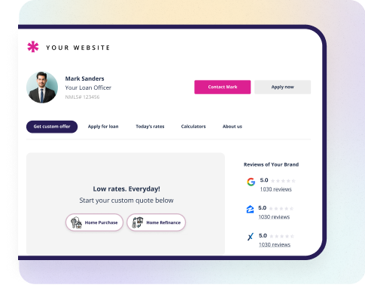
FROM LEFT TO RIGHT: BELOW ARE TABS WE WOULD INCORPORATE

Tab 1 – Today’s Rates
- API Intergration Optimal Blue (rate tables)

Tab 2 – Find My Loan
- Use “Find loan code” (Code attached)

Tab 3 – Get My Custom Rate
- API Integration, pricing engine with Optimal Blue (API Instructions Attached)

Tab 4 – Document Checklist
- This tab will contain code that will run the borrower through a series of questions to determine what documents they need for a smooth stress-free loan transaction (Code Attached)

Tap 5 – Apply Now!
- Link to preferred loan software, or LoanApp (iframe)

Tab 6 – My Home Value
- Plugin Iframe

Tab 7 – Find My Home
- IDX Real Estate Plugin (iframe)

Tab 8 Learning Center
- This will be somewhat of a webinar type of page where borrowers can watch videos, look at FAQ’s, etc. FAQ code is attached

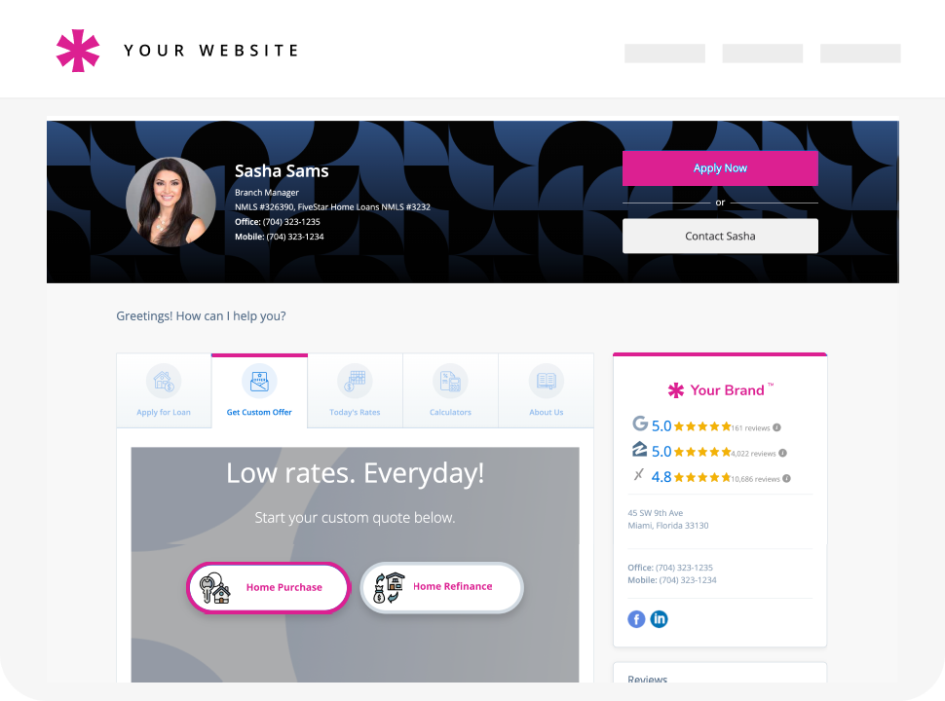

These are tabs on the 2nd Template. This tab is used to price a person’s loan, by asking a series of questions. Below is another example

Below is an image depicting a series of loan questions to price a loan It will use the answers to create a loan scenario and price it to pull rates via API:
This is the UI we currently use: https://theloanstar.my1003app.com/inquiry

This UI answers the question in the depicted image below:

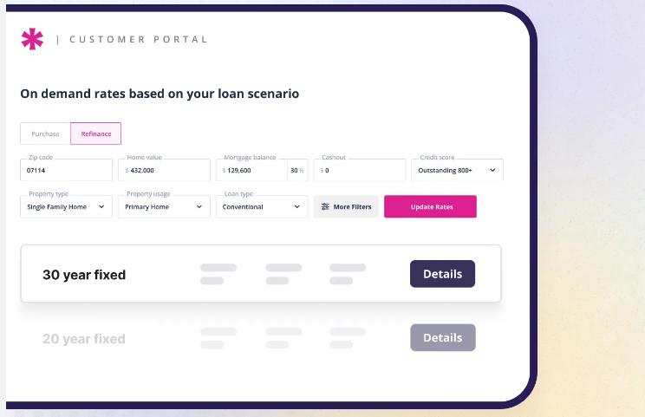
These are the loan results

Phone UI Below

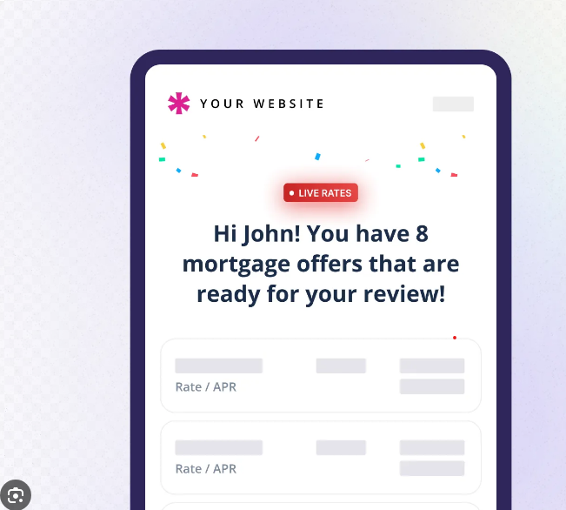

View borrower sees when logging in, and send via email in form of web funnel
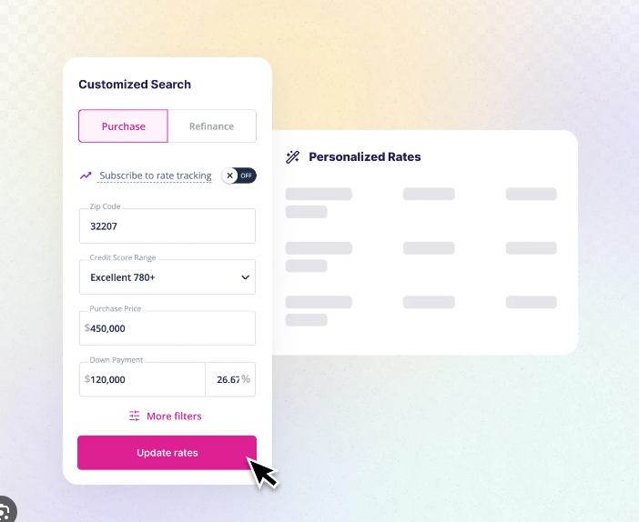
View of phone UI
View of rate table and refinance scenario quetsions
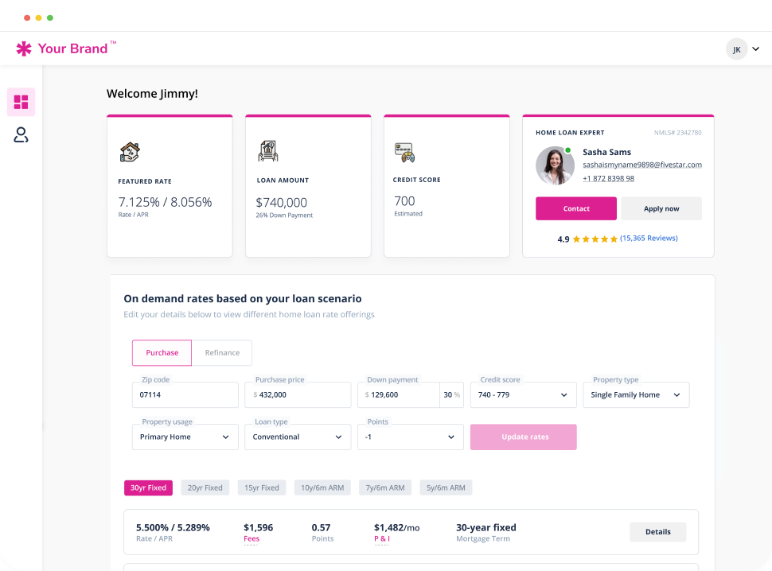
View of rate table and purchase scenario questions
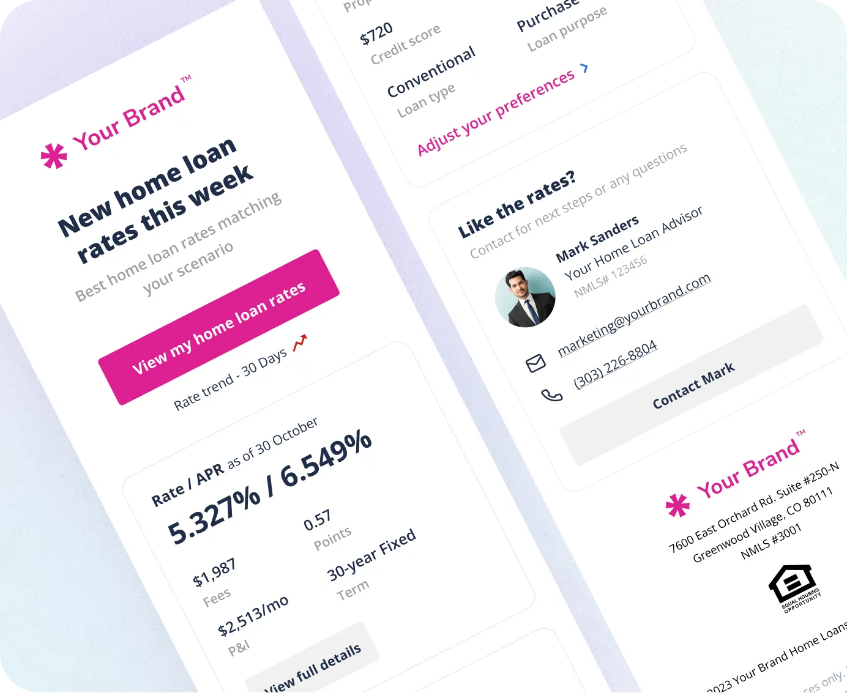
Image of funnel that goes out to clients via email each week. Upon clicking “View my home rates” they will be redirected to loan scenario questions and pricing engine
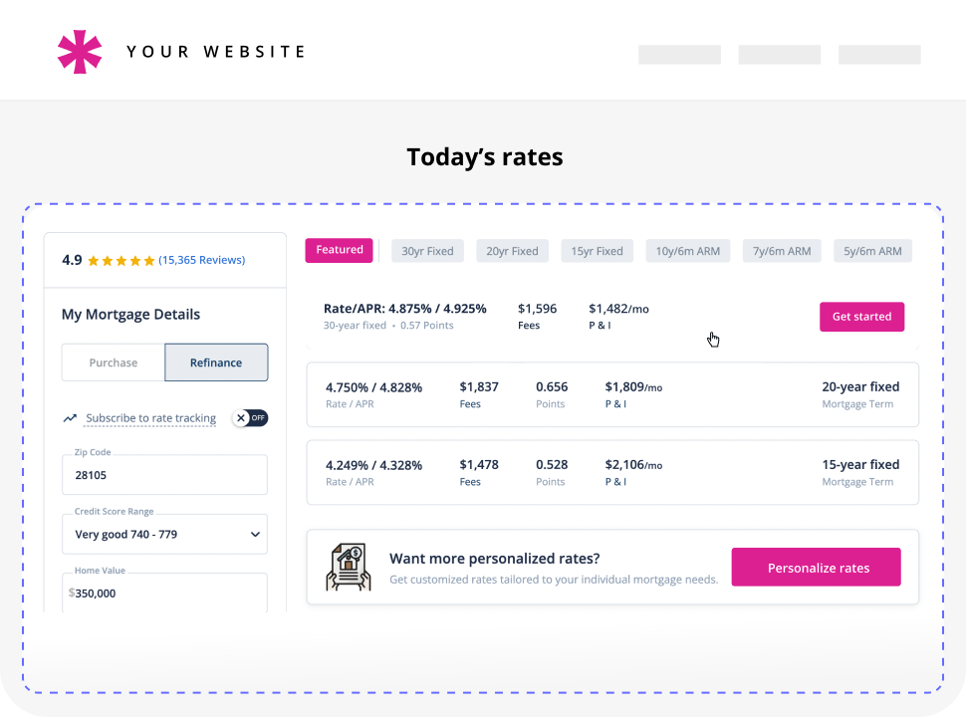
Image of Rate Table UI on desktop after customer inputs loan scenario questions

